Birla Institute of Technology & Science, Pilani
Second Semester 2013-14
Comprehensive Examination
Course : Electromagnetic Theory II (PHY F211)

Date : 05.05.2014 Max. Marks : 130 Time : 3 hours
Open-Book
Q1. Consider a charge & current free region V, bounded by a surface S. The electric and magnetic fields in this region are static.
a) Show that the integral of the Poynting vector over S,
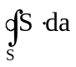
is zero. [Convert the integral into a volume integral and use appropriate properties of the electric and magnetic fields]
b) Show that the Poynting theorem :
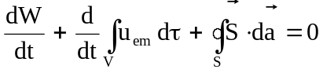
holds for this region.
c) If the region V has charge-current within it, will the integral of the Poynting vector over S be still zero? If not, how will Poynting theorem still hold? (6+4+4)
Q2. Inside a material medium, the 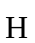field, rather than the 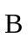field, is more relevant and a plane wave is described in terms of the 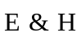fields. Consider a hypothetical linear medium in which both 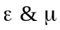are negative, and there are no free charge or free currents in the medium.
a) Show that in such a medium, plane waves :
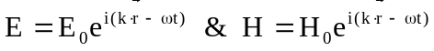
can propagate, that is, they will satisfy all the Maxwell equations, but with the condition that the three vectors 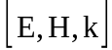 will form a left-handed triad. What is the relationship between 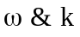for such waves?
b) Show that if only one of the two parameters, & , is negative, then will be purely imaginary. What does a purely imaginary k indicate? (7+5)
Q3. Consider an inhomogeneous and absorbing medium, in which the absorption (attenuation) coefficient varies along the x-direction (is a function of x alone). Show that if a plane electromagnetic wave of intensity 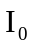is launched into this medium along the x axis (the incident surface is at x=0), then the intensity of the wave will vary as
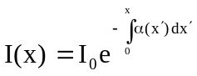
[Hint : Take a slice of the medium between x & 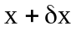, and relate 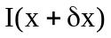to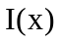, and hence obtain the differential equation for ] (10)
Q4. Consider an infinitely long line charge of uniform line charge density , aligned along the x axis. The line charge is being pulled along the positive x axis with a uniform velocity v, so that it produces both an electric as well as a magnetic field. Divide the line charge into infinitesimal elements 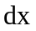, so that each element can be treated as a moving point charge, for which the fields are known. By integrating over the line charge, find the net electric and magnetic fields at point (0,h,0), and interpret these in terms of known results. (12+2)
Q5. A point charge q moves along the x-axis such the its position as a function of time is given as
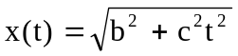
where b is a constant and c is the speed of light.
a) Find the instantaneous power radiated by this charge, and show that it is independent of time.
b) Find 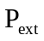, the power delivered by the external force moving the charge in the specified manner. Since the speed of the particle gets asymptotically close to that of light, you need to use the relativistic formula for kinetic energy. (8+7)

*************

Closed-Book
Q1. A piece of wire, bent into the shape as shown below, carries a current that increases linearly with time :
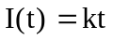
Calculate the retarded vector potential at the centre ‘O’, and hence, the electric field there? What produces the electric field, in the absence of charge? (10)

Q2. A relativistic point charge q, moving with a velocity v in a straight line, hits a target and comes to rest in time . Assume that the deceleration during this time is constant.
a) Show that the total electromagnetic energy radiated by the particle (Bremsstrahlung radiation) can be expressed as
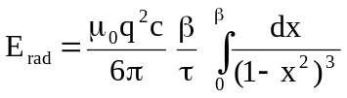
b) Complete the integral and show that the total radiation is :
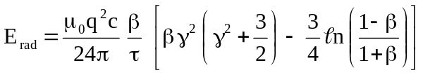
[Substitute 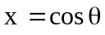 in the integral and use the integral formula
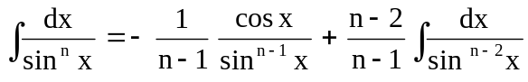 ]
c) How much Bremsstrahlung radiation is emitted when a 1 Gev electron is stopped in 1 ms? (10+8+3)
Q3a) Show that the electric and magnetic fields of an oscillating electric dipole, 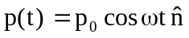, can be written as
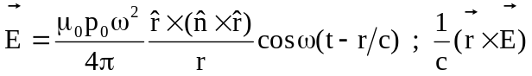
[Your starting point should be the already derived expressions for the two fields]
b) Obtain the time-averaged angular distribution of radiated power, 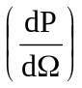, from an electric dipole of magnitude 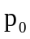, rotating in the x-y plane :
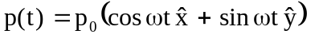
c) Find the total power radiated by such a rotating dipole. (5+10+3)
Q4a) A particle of mass m and charge q is hung from the ceiling by a spring of spring constant k. The particle is pulled down a distance d and released. How long will it take for the amplitude of the particle’s SHM to drop to 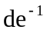? (6)
b) A point charge q is held fixed at the origin of coordinates and another point charge, also of magnitude q, is moved along the z axis with uniform velocity v, so that its z coordinate at time t is vt.
i) Find the force of the first charge on the second, and that of the second charge on the first, at time t.
ii) What is the net external force acting on the system of two charges, as a function of time? Where does the momentum delivered by this external force go? (6+4)

***************

